Test Report

1. For the existing split Students Database, creating a stored procedure and a trigger to maintain the statistic_tmp table, which stores the number of students in each city.
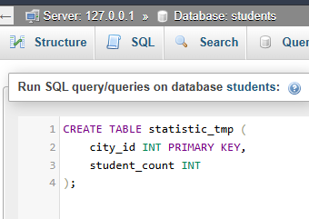

A) The Stored Procedure
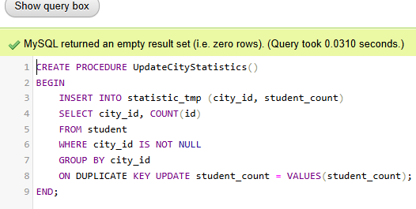

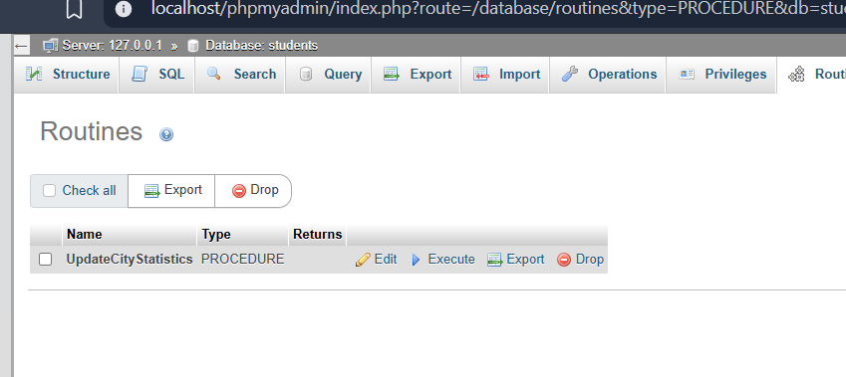
B) Trigger
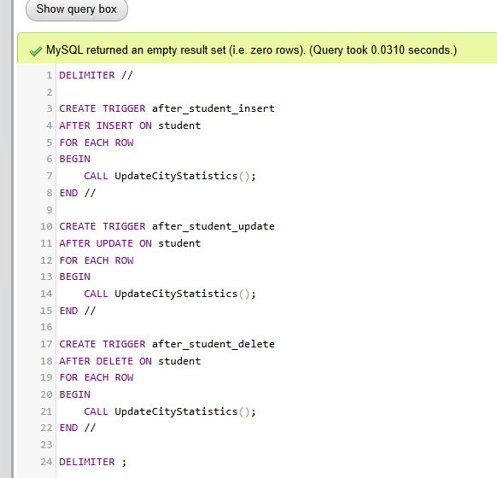
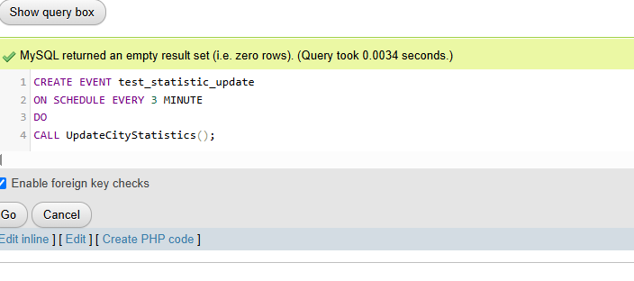
2) The Events(Testing 3min)
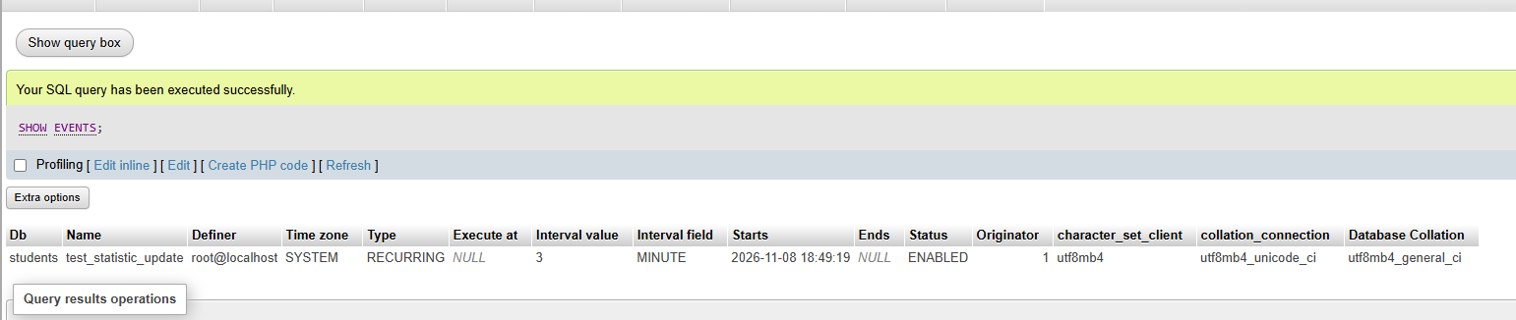
Result

Testing Event
a)Updating student count with 9999
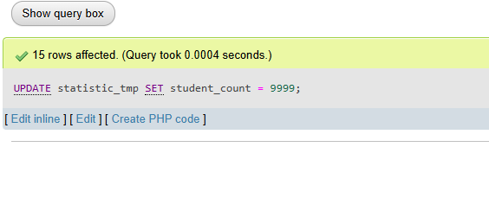

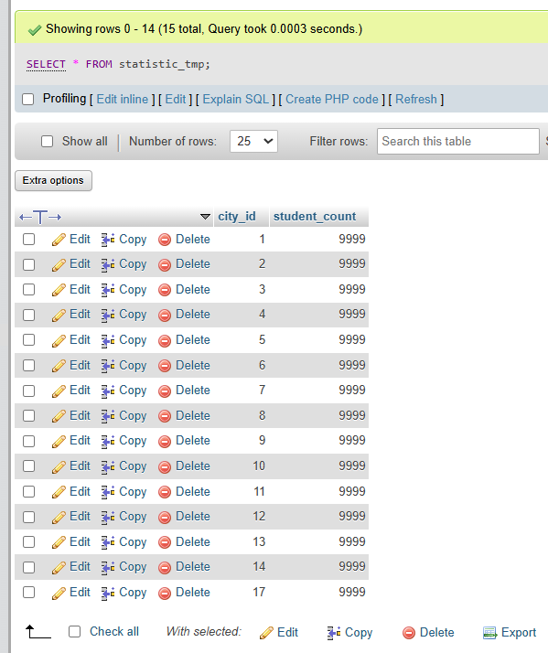
b)Data Completely Ruined with 9999

c)Event Triggered in Background and Automatically fixed all 9999 after 3 minutes

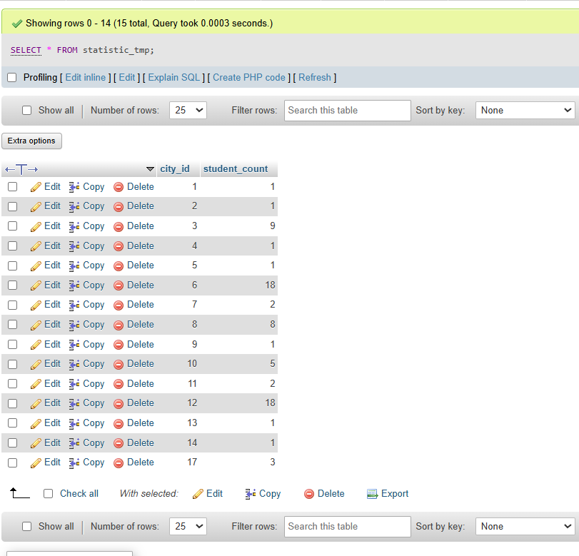

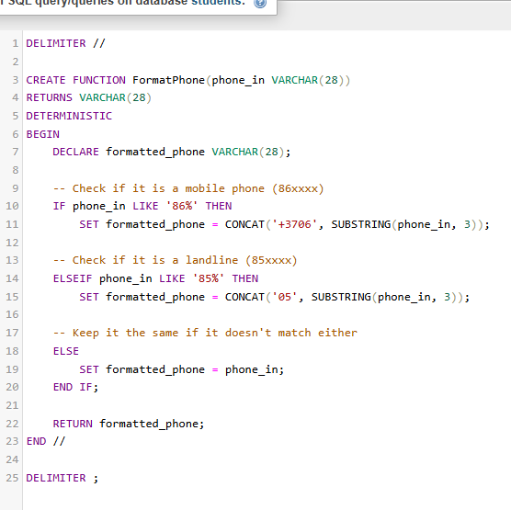
3) Phone Formatting Function

Testing of phone formatting function


